A Vision for Primary Health Care in the 21st Century

***From the WHO document “A vision for Primary Health Care in the 21st Century”[1]***

This section proposes a vision for a renewed PHC, to support the achievement of UHC and the health-related SDGs. This vision brings together the experiences and lessons learned over the past forty years and acknowledges the demands of societies today.

Individuals and communities are the central focus of all efforts to move towards PHC in the 21st century. People’s fundamental right to the best achievable state of health and well-being, and the world’s renewed commitment to social justice, are expressed through adequate social protection and concerted efforts to address the needs of those who are most disadvantaged. The broad determinants of health are addressed through actions that involve multiple sectors of government, civil society, and the private sector, and that sustain societies and environments that foster health and well-being. Close collaboration among sectors such as social protection, housing, education, agriculture, finance, environment, transport, energy, and urban planning, and industry allows people to live in health-promoting neighbourhoods that combine clean air, walkability and accessibility, green spaces, road safety and effective public transport. Priority consideration is given to those most in need, to ensure equitable access for all to healthy food choices, quality education, water and sanitation, waste management, adequate and affordable housing, and safe and meaningful work with appropriate remuneration.

Efforts to advance health and well-being are anchored in and informed by the community. People have access to the knowledge, skills and resources needed to care for themselves and their loved ones, making use of the full potential of information and communications technologies. Self-care and informal care are directly and explicitly linked to the formal service delivery sector through mechanisms that are effective and appropriate for the particular setting. The community effectively advocates for policies that respond to its specific health needs. Its members, including the most disadvantaged, are engaged as co-developers of the services they need to achieve health and well-being. The community’s needs and its social and cultural identity are reflected at all levels of policy and action and in the delivery of population and individual services. People are protected from adverse health outcomes through population-based measures, planned and delivered in consultation with those served. The measures include prevention and control of locally endemic diseases and disease outbreaks, prevention of noncommunicable diseases, and information and education on prevailing health problems, including major risks, and the methods to prevent and control them. At the community level, population-based and individual services are well integrated and coordinated and are explicitly accountable to the people, enabled by purposefully designed health information systems. People do not experience financial hardship because of spending on the health services they need. They benefit from interventions that are delivered at the right point along a continuum, where effectiveness and equity are maximized and cost is minimized. In practical terms, this implies prioritizing the delivery of interventions upstream, earlier in the pathophysiological pathway and, where possible, outside the health care setting.

When clinical care is needed, it is delivered to combine the best outcome with optimal use of resources and patient satisfaction (the triple aim), addressing the integrality of people’s health needs. The interventions needed to attain the highest standard of health are delivered along the continuum of care, taking into consideration a life-course approach. Whereas previously the notion of levels of care has been useful in shaping health systems, in the 21st century the notion of a continuum of care is more consistent with the coordinating centers and care pathways, and with a system centred on people rather than on services. This continuum ranges from actions delivered exclusively through a multisectoral approach, to public health services delivered to the population, to individual primary care, to coordination with highly specialized consultation services for rare and complex health problems. People expect the health system to lead to the best possible standard of health through optimally coordinated and streamlined quality services. This can be achieved through: early action along the continuum of health actions of proven effectiveness (i.e. promotion and prevention over treatment and rehabilitation when possible), proximity to people’s everyday life (i.e. community-oriented and locally delivered services oriented to supporting self-management over care delivered in highly centralized centres), and efficiency in the use of resources (i.e. appropriate referral and integration of services along evidence based pathways of care to reduce duplication of services, improve communication to facilitate early diagnosis, and improve safety). In the context of primary care, people are supported to express their needs, preferences, and values.

A trusted multidisciplinary primary care team supports patients in prioritizing and identifying care goals. In individual patient care, the team takes into consideration the patient’s cultural preferences and stage of life, across a wide range of problems (mental and physical, chronic and acute, communicable and noncommunicable, from immunization and prevention to treatment, rehabilitation and palliative care). Teams are responsible for assessing the medical needs of the patient, providing safe evidence-based, cost-efficient management through extensive use of health technologies and information technology, and coordinating additional or specialized services for patients who need them through wider PHC networks. They facilitate the provision of care at the right level along the pathway of care and across diseases, and act as the focal point for all medical services delivered to the patient, thereby leading the response to multimorbidity through a whole-person approach and a life-course perspective. People are familiar with the members of their primary care team and know how to access them. There are no significant financial barriers to access. In return, members of the primary care team not only are but feel accountable to those in their care, demonstrating this through access, compassion, and responsiveness. Teams vary in size and composition depending on the local context and availability of expertise, and may include family physicians, nurses, midwifes, social workers, nutritionists, community health workers, health promoters, registered or regulated traditional medicine practitioners, dentists, pharmacists, rehabilitation workers, counsellors and opticians. There are many other potential members, including some taking on new roles in evolving systems, such as patient navigators and life coaches.

As health systems evolve, in line with each country’s technical and financial resources, packages of services aimed at dealing with specific health problems are progressively replaced by fully integrated, comprehensive, people-centred primary care. Primary care becomes the natural place of delivery for most health care processes (diagnosis, treatment, rehabilitation, and palliative care) with the highest levels of quality and safety. This transition permits the delivery of health services that are required to maintain or restore health and not those selected primarily by third parties on the basis of cost savings or other objectives. The performance of the health system is measured and publicly reported in terms of quality of life, functioning, longevity, and incidence of disease, as well as patient experience. In weaving together multisectoral policy and action, empowered people and communities, and health services at both the population-based and individual levels, PHC in the 21st century ensures healthy lives and wellbeing for all at all ages.

Box 2: The example of hypertension-

As an example of how this vision of PHC can be applied in a concrete case, consider hypertension. This would be addressed through multiple interlinked actions, e.g. the regulation of salt in food, the promotion of physical activity through public health campaigns, and the development of enabling environments through urban planning. People at risk for hypertension or actively dealing with it would have information readily available to them as a result both of their own actions and through public health campaigns. They would feel supported by community networks that included empowered advocates who regularly engaged with the health system to articulate their needs. For the vast majority of the population with established hypertension, clinical management would be provided through primary care, while individuals with highly complex hypertension would be referred on to specialized care following evidence-based pathways.

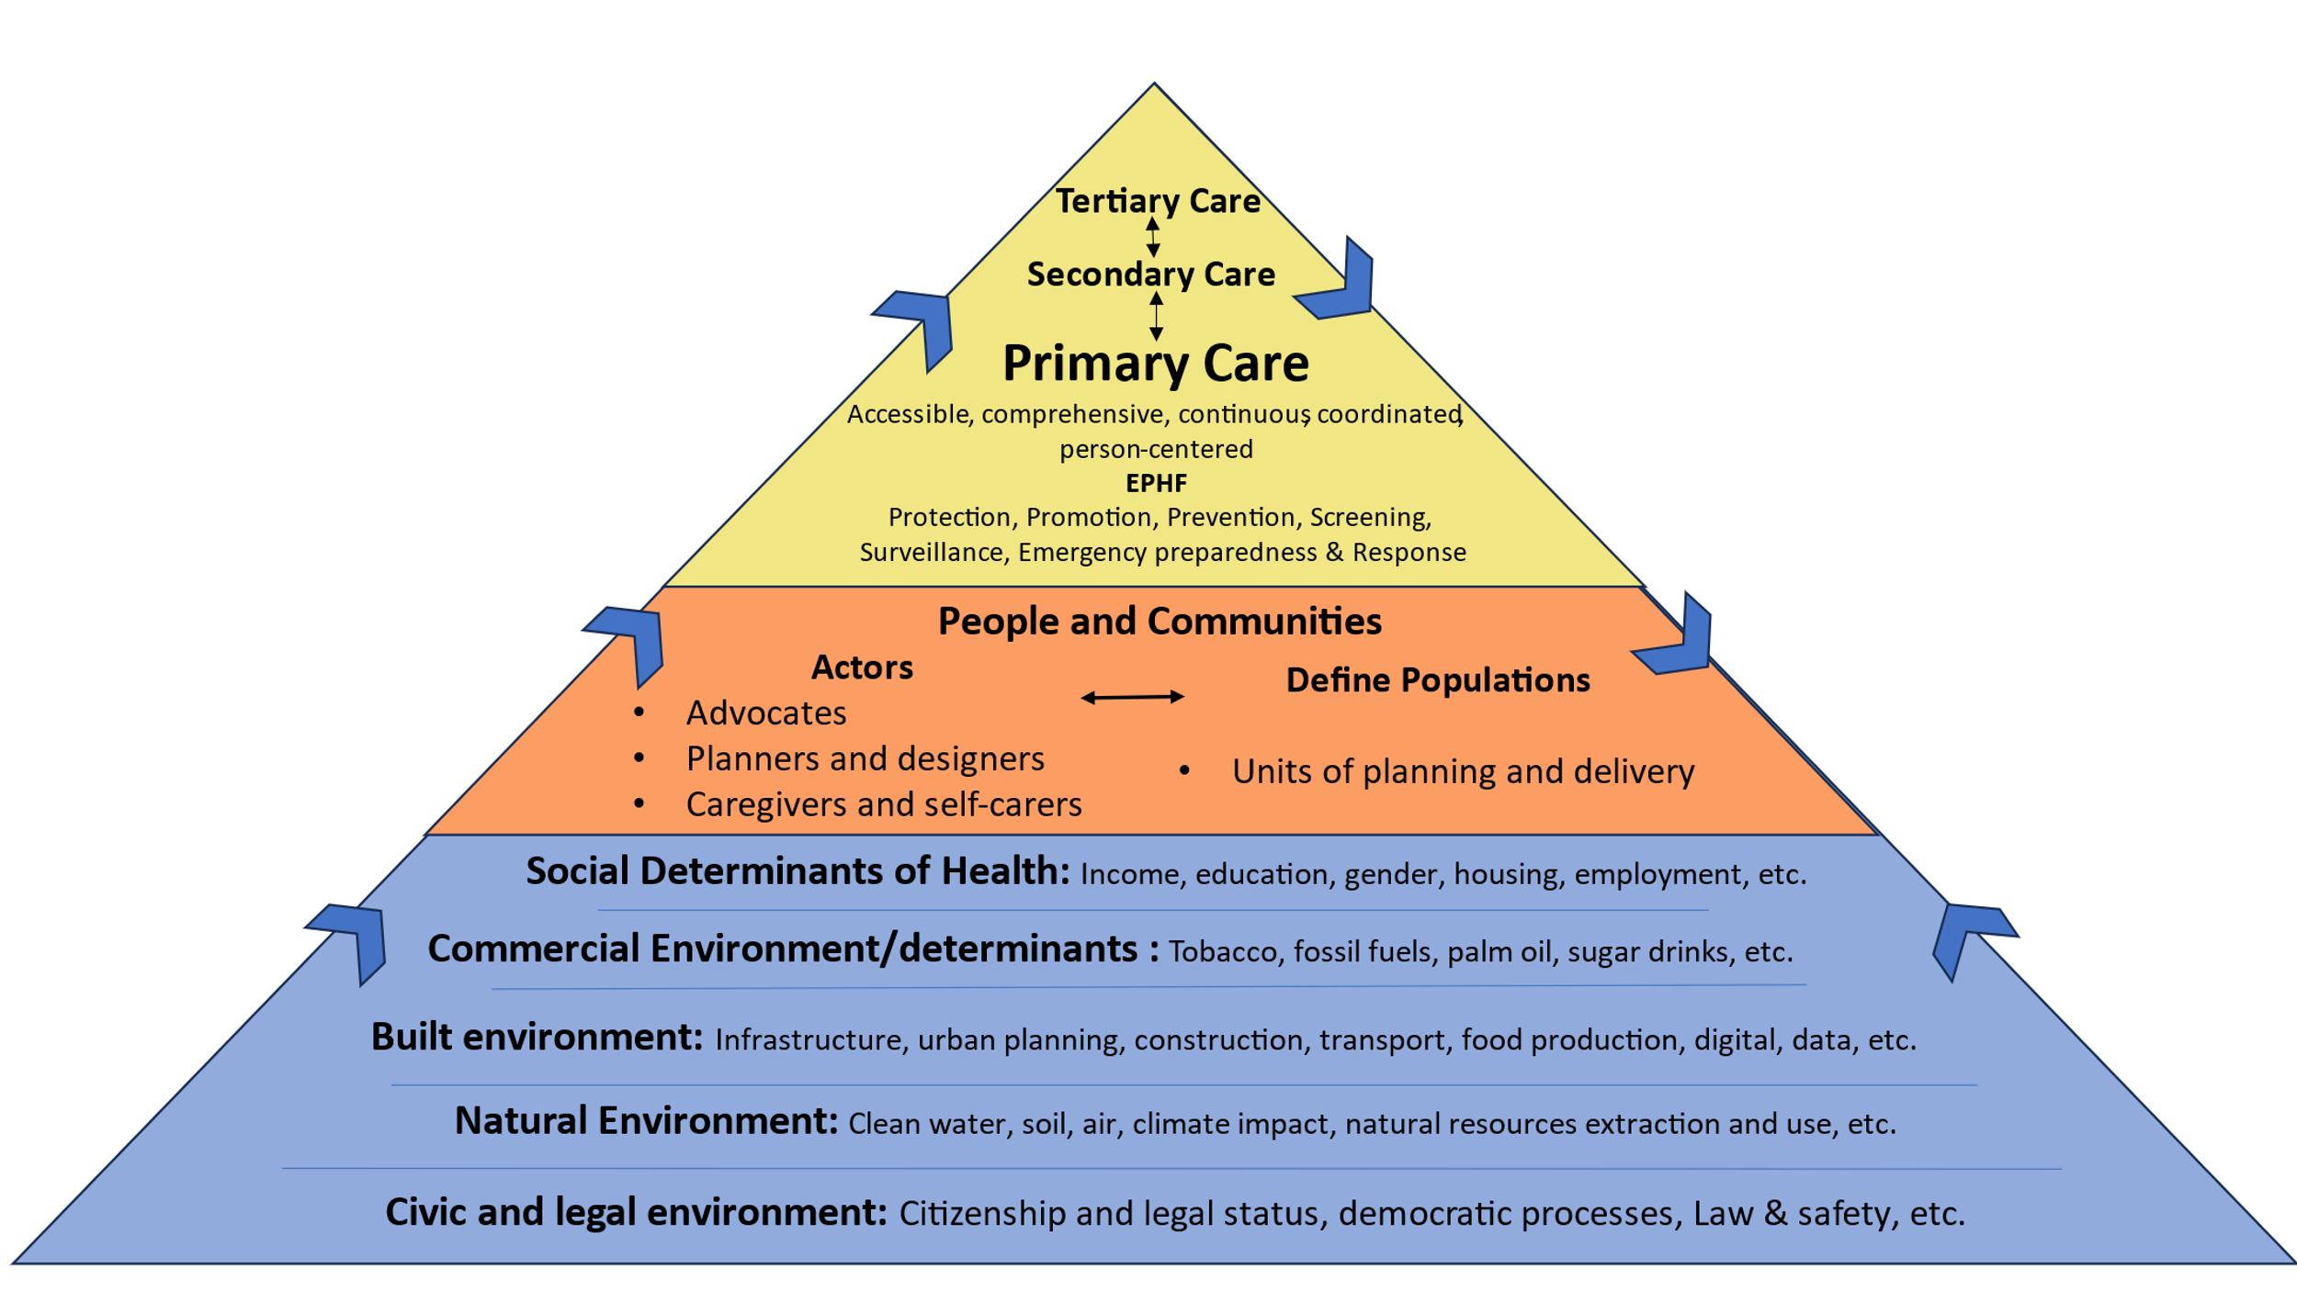

K. D. Rouleau

1. A vision for primary health care in the 21st century: towards universal health coverage and the Sustainable Development Goals. Geneva: World Health Organization and the United Nations Children’s Fund (UNICEF); 2018 (WHO/HIS/SDS/2018.15). Licence: CC BY-NC-SA 3.0 IGO.