**Ali Damji**-Dr Damji is a family physician and addiction medicine specialist at Credit Valley FHT & FMTU and the Mississauga & Halton Rapid Access to Addiction Medicine Clinic. He is an Assistant Professor in the DFCM, and an Investigator at the Institute for Better Health. He is the Division Head of Primary Care at Trillium Health Partners, where he leads approximately 300 family physicians. He is a health systems leader at local, provincial, and national levels and has a Master of Science in System Leadership and Innovation from the University of Toronto.

**Ammar Bookwala**- Dr. Bookwala has been a community family physician at Streetsville Medical for four years. He also works in long-term care and palliative care. He is particularly interested in geriatric and palliative care, but he also enjoys practising cradle to grave family medicine. He is also the Trillium Health Partners Faculty Development Lead.

**Betty Chen**- Dr. Chen is a family physician at Women’s College Family Practice since 1999, with a comprehensive academic practice including low risk obstetrics. She is interested in clinical teaching and education scholarship, and loves mentoring in all of these areas. In her life outside of medicine she enjoys traveling with her family, engaging in a variety of physical activities, knitting and learning new things.

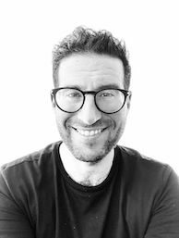

**Bradley Lichtblau -** Dr. Lichtblau is a Family Physician. He has a comprehensive family practice at the Women’s College Hospital (WCH) Family Practice Health Centre.

**Erum Raheel**- Dr. Raheel is a family physician, FHO lead, and the Medical Director of Scarborough's Oasis Family Health Centre. She is an Assistant Professor in the DFCM. Dr. Raheel has always maintained an active practice, serving a varied patient group and taking on clinical leadership responsibilities in patient care and community service. Dr. Raheel is passionate about providing a high standard of care for visible minorities in Mental and Women’s health.

**Gina Yip**- Dr. Yip joined the Markham FMTU/ Health For All FHT in 2012. She has been the Quality Improvement Program Co-Director since 2019. She also served as the Undergraduate Program Co-Director and Chair of the Quality Improvement Committee from 2013-2019. Her special interests include palliative medicine and narrative-based medicine. Dr. Yip completed her MD and Family Medicine residency at the University of Toronto. She also has a Master of Health Sciences degree in Community Health and Epidemiology from the University of Toronto.

**Jane Chow**- Dr. Chow is a Community Family Physician affiliated with Sunnybrook Health Sciences Centre. Her main practice is at Yonge and Eglinton, and has been in comprehensive family medicine for over 9 years. She has other community practices in Markham, Etobicoke and the downtown core. She is an Assistant Professor with Temerty Faculty of Medicine and the Physician Recruiter and Undergraduate Faculty Development Lead with the DFCM.

**Julia Rackal**- Dr. Rackal is a family physician at St. Michael's Family practice unit - the 61 Queen Site. She has practiced there since 2006, and was born at that same hospital, in 1976! Her practice is a general family practice, with no special focus. She has an interest in nutrition, meditation and health and considers her ability to listen, with presence, to be her superpower.

**Mruna Shah**- Dr. Shah is a primary care physician practicing comprehensive family medicine in Pickering. She is an assistant professor at the UofT. Her academic interests include the social determinants of health, health equity, medical education and faculty development. She is the co-founder of the ROAD to Equity Certificate Program and Director of the Global Health, Diversity and Health Equity Program with the DFCM at SHN. Her hobbies include diving, travelling, cycling and yoga.

**Tuhina Biswas**- Dr. Biswas is a family physician at Women’s College Hospital and has been in practice for over 15 years. She has an interest in Women’s health, obstetrics, minor procedures and narrative medicine.

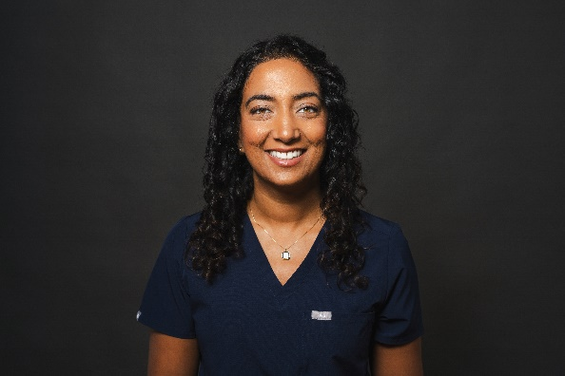**Nikita Patel** - I am a UofT Med Grad, who trained at Women's College Hospital Academic Family Health Team. I briefly worked in a few community clinics but have been a staff physician at WCH Family Health Team for 10 years. I lead the home visiting program for complex geriatric patients and am also the Undergraduate Program Director for Family Medicine. I work clinically with a practice of just over 900 patients, while teaching clerks and residents. I teach several pre-clerkship courses to balance out my clinical time. Outside of work, I have a 3 year old daughter with my partner, live in an intergenerational home and enjoy travelling, reading, jogging/moving my body in nature and trying new food to unwind. Looking forward to meeting you and growing together!

**Anne Biringer** - I have been working at Mt Sinai Academic Family Health team since 1982 (!) where I have a comprehensive family practice. I have a special interest in family medicine perinatal care - including clinical (ie catching babies), teaching about it, doing research about it and doing policy work related to it. This interest has also taken me to many under-resourced countries where I have been a part of multiprofessional teams teaching about safe childbirth. As I approach retirement, this is an opportunity for me to reflect on the tremendous joy that my career has brought me and, hopefully, to share some of that joy.

**Farhan M. Asrar** is Associate Professor with DFCM and Cross-Appointed with Dalla Lana School of Public Health. Trained in the dual Public Health & Preventive Medicine and Family Medicine residency programs, Dr. Asrar is currently practicing as a family physician in Mississauga. He also holds leadership roles with the Trillium Health Partners, being the Physician Research Lead for DFCM's 2 teaching sites based at Credit Valley Hospital and Mississauga Hospital; and Physician Lead for THP@Home. Farhan has an interest in clinical medicine, teaching (peers and learners), and research. He also serves as a national mentor to support Equity, Diversity, Inclusion and Accessibility (EDIA) through an initiative under the Foundation for Advancing Family Medicine. Farhan's research and teaching interests are in family medicine, public health, environmental health, space medicine, innovative solutions for healthcare; and EDIA

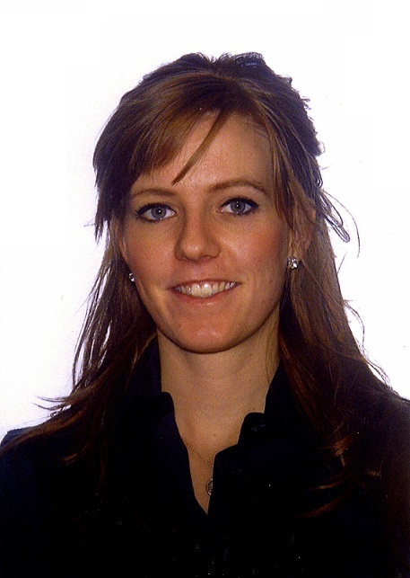**Katherine Gibson** is a family physician at Access Alliance Multicultural Health and Community Services. Prior to her medical training, she obtained a Masters in Public Health from the University of Toronto. She subsequently completed her medical school at the University of Calgary, and family medicine residency at Queen’s University in 2014. She then served as a Medical Officer with the Canadian Armed Forces, during which time she had the opportunity to work across Canada as well as in Panama, El Salvador, Lebanon, Iraq and the Netherlands.

Upon completion of her military service, she began working as a family physician in the CHC sector and continues to work with a primarily newcomer patient population in her current practice. She takes a particular interest in addressing the social determinants of health and working on an interdisciplinary team.

**Paula Molnar** - I have been a full time family physician with active privileges at the Trillium Health Centre in Mississauga for more than 25 years.    I practiced family medicine with a busy obstetrical practice for the first 8 years of my career.  I then went on to help develop the palliative care program at Trillium and acted as Lead Physician for 3 years.  I continue to practice family medicine as part of the Summerville Family Health Team, having been a member since its inception in 2007.  In addition I do some teaching of medical learners and residents as part of the Department of Family and Community Medicine at U of T.

**Dr. Anjuli Little** completed her medical school, and residency in Family Medicine, at the University of Toronto. She practices downtown Toronto as a family physician and walk-in doctor, with a special interest in women’s health, dermatology, and travel medicine. She holds staff appointments at Michael Garron Hospital, is an executive member of the East-Family Practice Primary Care Network in East Toronto, and an Ontario MD Lead of Rocket Doctor, a virtual family practice centre, providing care to patients across North America.

**Yasna Mehdian** - My name is Yasna Mehdian, and I’m a recent graduate (as of July 2024) of the University of Toronto’s Family Medicine residency program at Mt. Sinai Hospital, where I am currently practicing comprehensive outpatient family medicine as a staff.  I have also recently taken on the role of Undergraduate Program Director at Sinai’s Family Medicine site, where I enjoy working closely with medical students. My special interests lie in academic program and curriculum design, teaching, and mentorship. I am also pursuing a part-time Masters in Science and Community Health with a focus on Health Practitioner Teacher Education at the University of Toronto. Looking ahead, I aim to integrate GP psychotherapy into my practice as well. Outside of medicine, I am an avid musician and a passionate Toronto Maple Leafs fan.

**Dr. Anna Holland** is a comprehensive family physician in the academic Urban Family Health Team at St. Joseph’s Health Centre (SJHC) Unity Health Toronto. She brings her years of community medicine practice experience and knowledge of different models of care to her teaching and comprehensive generalist practice. Dr. Holland is also a specialist in Addiction Medicine in both an inpatient and outpatient capacity. She is a Lecturer at the University of Toronto’s DFCM where she teaches medical students, residents and fellows. She pursues avenues of scholarship and research that are pragmatic and inspired by her clinical experience. As a clinician, she advocates for her patient’s needs and as a scholar seeks data to support health care system transformation.

**Susanna Fung** is a community Family Physician and Assistant Professor at the University of Toronto. She is the Quality Improvement Co-Director in the Department of Family & Community Medicine at the Scarborough Health Network. She has an interest in women’s health, health equity, and medical education.

**Augustine Marchie** - Graduated from the family medicine program at McMaster University in 2010. Completed a fellowship in emergency medicine at Western University Ontario. Currently working at an urgent care clinic since 2015. I am interested in addressing the challenges and joy of working in primary care.

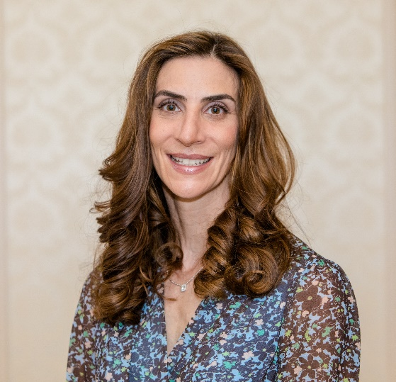**Dara Maker** - I am a comprehensive family physician at Women's College Hospital Family Practice.  I knew since the beginning of my medical training that I was interested in family medicine as I like keeping people healthy - not just treating them once they are sick.  I completed my Family Medicine residency at Women's College Hospital and stayed on since - nearly 18 years now! Upon completion of my two-year residency, I completed a PGY3 in Women's Health. I have used those skills both in my daily practice and at the Bay Centre for Birth Control where I work one day per week. In addition to my clinical work, I have been involved as a clinician educator, primarily with undergraduate medical education and assessments.   Currently, I am the Medical Director and Associate Department Head of the Women's College Hospital Family Practice unit.

**Evangeline Seganathy** - Dr. Seganathy works as a family physician providing comprehensive care while also teaching residents and medical students at the Summerville Family Health Team. She also works in the longterm care setting.  She is the undergraduate hospital director for Trillium Health Partners.