Process and Resources for Underperforming Faculty:
A DFCM guide for Site and Division Heads, Program Directors and other Educational Leaders

Within the DFCM, faculty are most often identified as needing monitoring or attention through LACT evaluations, however there are a variety of other assessments that may bring a faculty member to the attention of their Site or Division Head, such as small group teaching scores, self-evaluations, or other evaluation data from undergraduate, postgraduate, continuing education, or faculty development. The Site or Division Head should review all available data before meeting with the faculty member.

For faculty who may need monitoring, review the data together and explore through guided reflection whether the data appropriately represents the usual approach of the faculty member and/or whether there may have been any unusual circumstances or additional context that is relevant. Develop a mutually agreed upon learning and follow-up plan and timeline. For single or initial issues relating to pedagogy, content, format, or expectations, identify the target/goal with the teacher and recommend resources/suggestions to improve teaching with a plan for future teaching discussed. See below for resources/opportunities to consider as part of the learning plan.

For faculty identified as needing further support, we recommend the following approach:

Prior to an initial meeting with the faculty member:

For the educational leader for information gathering and process planning:
What is the nature of the problem? Is this an individual faculty teacher issue, an organizational or systems issue or both?

NATURE OF THE PROBLEM | DATA PROVIDED/  TO BE COLLECTED | POSSIBLE INTERVENTIONS | WHO COULD/  SHOULD BE INVOLVED?
Failing to meet expectations of specific learning responsibility (e.g. not completing assigned assessments, failing to implement the curriculum as designed) | - Learner Assessment of Clinical Teacher (LACT)  - Student comments  - Course director and/or peer feedback/ observations | - Clarification regarding role/responsibilities  - Faculty development specific to role/ course/setting | - Dean/Vice Dean (university)  - Education Director (practice site)  - Vice Chair Education (department)  - Course or program director
Lack of rapport with learners (e.g. lack of engagement with the learner/learning relationship) | - LACT  - Comments from students and peers | - Faculty development specific to role | - Vice Dean  - Vice Chair Education (department)  - Course of program director
Role modeling (e.g. modeling of poor professional behaviour) | - LACT  - Document concerns  - How is this impacting teaching? | - Refer to Faculty of Medicine Standards of Professional Behaviour for Clinical (MD) Faculty | - Dean/Vice Dean (university)  - Education Director (practice site)  - Vice Chair Education (department)
Lack of appropriate supervision of trainees | - LACT  - Details of situations where trainees felt unsupported  - Evidence of impact on patient care |  | - Vice Chair Education (department)
Uncivil behaviour (e.g. verbal aggression, non-verbal intimidation) | - LACT  - Documented concerns from students/peers/ colleagues | - Refer to Faculty of Medicine Standards of Professional Behaviour for Clinical (MD) Faculty | - Dean/Vice Dean (university)  - Education Director (practice site)  - Vice Chair Education (department)
Trainee in trouble who is blaming teacher | - Trainee assessments  - Clarify nature of issues from multiple sources/perspectives | - Consultation with Director of Learner Experience and/or Associate Dean Health Professions Student Affairs | - Course director  - Vice Chair Education (department)  - Education Director (practice site)
Clinical concerns (e.g. patient safety, effective practice) | - Clinical Care  - If feedback is coming from learner, consideration needs to be given to the evidence and their stage of learning along with collaboration from other sources | - Defer to clinical leadership before deciding on implications for teaching responsibilities/roles | - Dean/Vice Dean (university)  - Education Director (practice site)  - Vice Chair Education (department)
Complaints of serious misconduct (e.g. criminal behaviour) | - Information from peers/learners/patients  - Trainee mistreatment reports | - Engage legal counsel as per university/ hospital policy | - Education Director (practice site)  - Site Head

Adapted from the Guidelines for Teaching Performance and Support Process, Temerty Faculty of Medicine, University of Toronto, July 2021

For the faculty member for self-assessment purposes:
Please ask the faculty member to use this grid to identify their areas of concern, areas of weakness and areas of strength:

KNOWLEDGE | ATTITUDES | SKILLS
Identify challenges and strengths (e.g. gaps in clinical knowledge) | Attitudinal challenges (e.g. are you experiencing difficulties with motivation, support for teaching, and frustrations with teaching). | Skill deficits often overlap with gaps in knowledge. Identify strengths as well (e.g. interpersonal skills, technical skills, clinical judgment, organization of work).

TEACHER | LEARNER | SYSTEM
Are there any perceptions, expectations, feelings, personal experiences/ problems or stresses that are affecting your role as a teacher? | Do you feel there are learner factors which are affecting your ability to teach? | Are expectations, responsibilities, standards and/or workload expected of you (by the department/university) clear?

Adapted from: Figure 1, Steinert Y. The problem learner: whose problem is it?
AMEE guide No. 76. Medical Teacher 2013; 35: e1035-45

During the meeting:

1. Suggest use of the R2C2 model to explore teacher’s reactions to the data provided. Refer to “Tri-fold: R2C2 for feedback with practicing physicians” for examples of phrases to use in the feedback conversation.
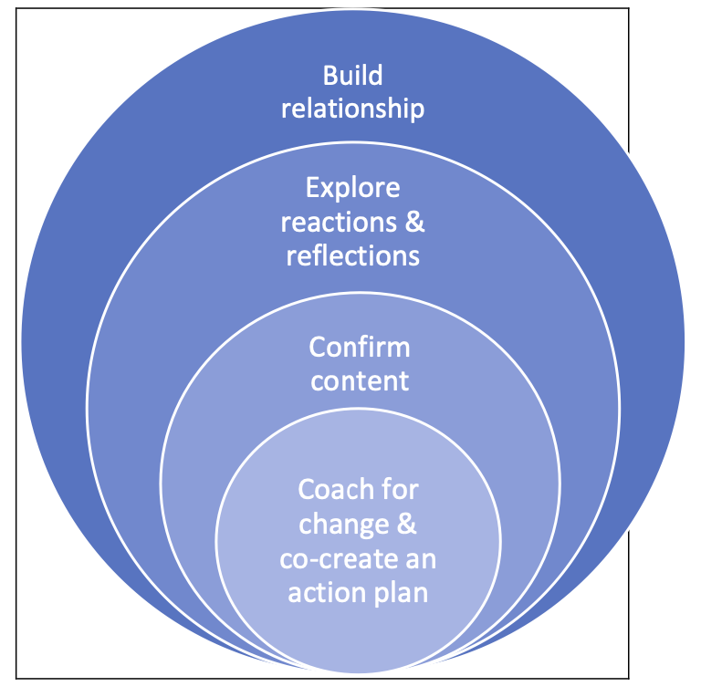
Coach for change and co-create an action plan: To ensure the physician understands, reflects upon and assimilates the content of the report in order to develop an achievable action plan.
Confirm content: To ensure the physician is clear about what the data mean for their practice and the opportunities they suggest for change.

Explore reactions and reflections: To ensure the physician feels understood and that their views are heard and respected.
Build relationship: To engage the physician, build relationship, mutual respect and trust.

R2C2 Evidence-Informed Facilitated Feedback and Coaching: Physicians In Practice Version
Adapted from: Sargeant et al., Academic Medicine, 2015, 2018; Armson et al., Medical Education, 2019.
To be used in discussions with practicing physicians about their performance data.
2. Support the faculty member to develop a feasible action plan using the framework below, based on the R2C2 Feedback Model.

Describe specific, observable change/s you intend to make.
For each:
- What is your goal?
- What specific actions do you need to take? When will you begin? When do you think you will see results?
- What resources will you need? Who can help you? What learning might you need?
- What might get in the way of making the changes?
- How will you overcome that?
- How will you know you have achieved your goal?

3. Maintain clear documentation of those present, key points discussed and next steps to include:
- A plan for further assessment(s) (if required)
- Additional data (if required)
- Expected outcomes
- Intervention(s) (see below)
- Monitoring plan
- Timelines
- And who is involved with each of these

Resources and Opportunities to Enhance Teaching Effectiveness

Other methods of teacher assessment:
To gather further data and develop a more fulsome and holistic picture of teaching effectiveness. Some examples include:
- Near-peer assessments of teaching sessions
- Learning outcomes
- Teaching portfolios
- 360-degree evaluations

Faculty development opportunities:
  - DFCM
    - BASICS for New Faculty
    - Academic Fellowships and Graduate Studies
    - INTAPT course
  - Centre for Faculty Development
    - Teaching and Learning in the Clinical Context
    - Stepping Stones
    - Education Scholars
  - Office of Faculty Development (MD Program)

For Faculty needing more individualized support:
The Centre for Faculty Development also has two offerings for faculty needing additional support or remediation.

- Individual faculty consultation with CFP Director. There is a fee for this consultation, and generally the faculty member and/or nominator will receive a report with recommendations.

- Enhancing Teacher Performance (ETP) program (https://centreforfacdev.ca/enhancing-teacher-performance/)

The ETP program seeks to maximize teaching excellence competencies through guided coaching, customized learning activities, simulated teaching encounters and debriefing, targeted CFD workshops, and curated resources. All are selected to enhance the teacher’s knowledge, skills, and attitudes so that they may positively impact the learning environment for their learners. This program seeks to create a confidential, supportive, and customized learning environment for faculty members to tackle their development goals as teachers.

The program is a 1-to-1 coaching based program and therefore has flexible enrollment. The program participant is matched with a faculty development coach who will co-create, through a series of initial consultations, a customized faculty development plan. This plan will be implemented over the course of a 3-6 month period, based on when workshops are available, individual faculty needs, and when customized sessions can be arranged around clinical/teaching schedules. The program is designed to be highly flexible and adaptive to needs, with a curriculum that addresses the unique goals of each participant.

Cost $6900 – usually split between the faculty member and the site, division and/or department.

Please contact Latika Nirula, Director of the Centre for Faculty Development, for further information on either of these offerings. latika.nirula@unityhealth.to

